# **EXERCISE 1: DISPLAY THE MOVIES**

When you run index.html file you will see a list of movies like in the picture below:

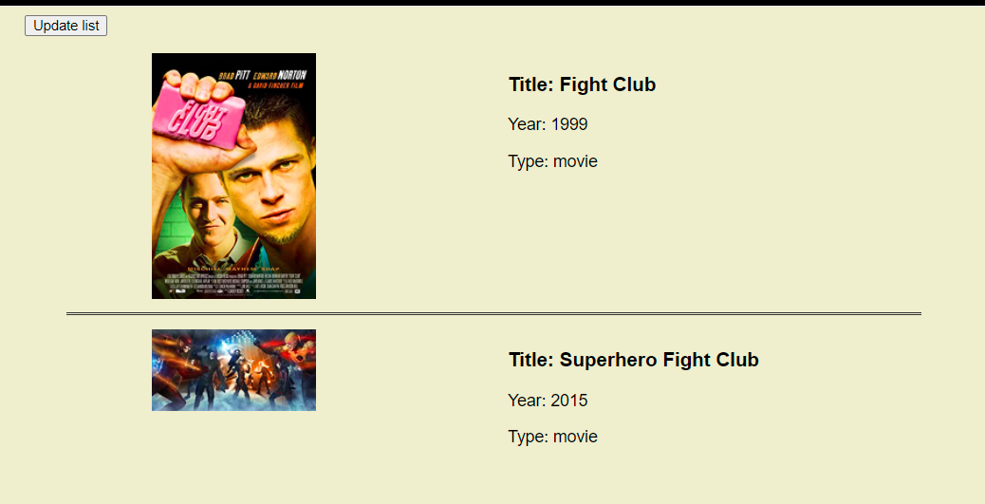

**TODO:** Complete the functions in app.js to be able to display the movies from the ***data that already exist*** in app.js like the picture:

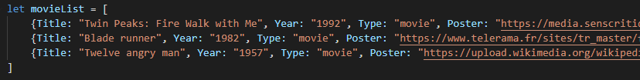

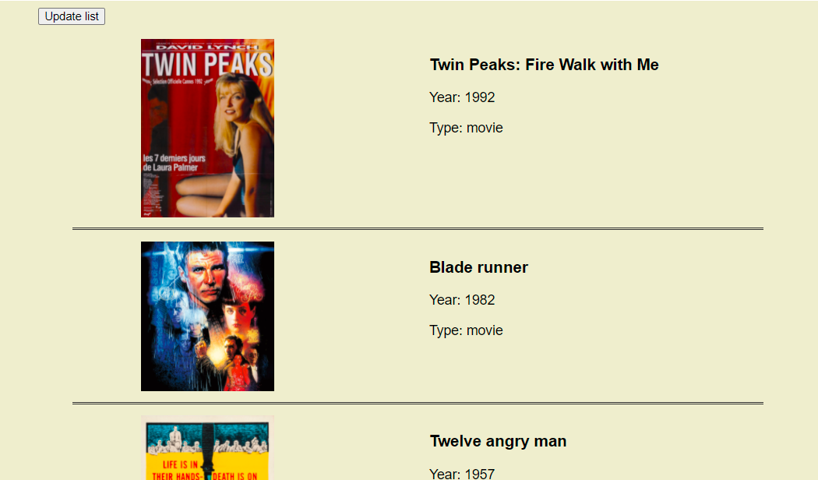

# **EXERCISE 2: GET MOVIES FROM API AND DISPLAY ON CONSOLE**

You have a REST API URL: [*http://www.omdbapi.com/?apikey=fab8d88e&s*](http://www.omdbapi.com/?apikey=fab8d88e&s)

**TODO:** Use **AXIOS** to get the data from this endpoint with the **parameter** that get from **user** **input**.

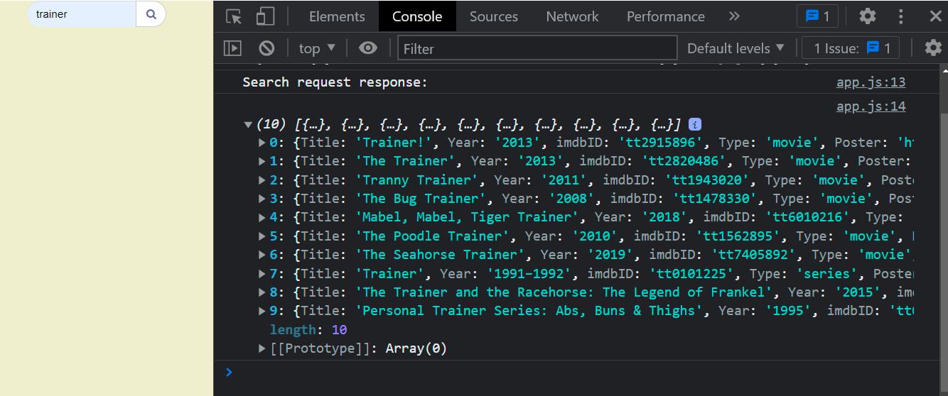

# **EXERCISE 3: SEARCHING MOVIE (EX 3 = EX1 + EX 2)**

To complete exercise 3, you need to combined exercise 1 with exercise 2.

**TODO:** Use the functions in **exercise 1** to display all the data that you get from API in **exercise 2**

**Additional feature needs to do:**

* If the input from user **doesn’t match** **any** **data in API**, display *“No movie matches this search request in our database”* as in the picture:

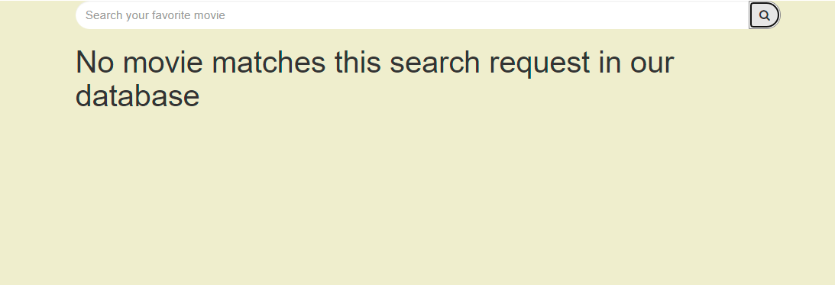

* Your research still keeps information even if you refresh the page.

